

**INDIAN INSTITUTE OF TECHNOLOGY, MANDI**

*AVISHKAR PROJECT*

2016

PROJECT: **CUBINATOR (Group 19)**

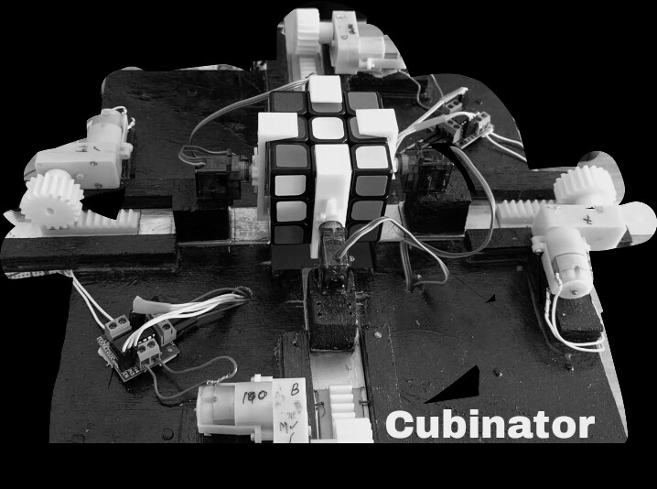

**GROUP MEMBERS:**

UTKRISHT DHANKAR (B15138)

UTKARSH KUNWAR (B15238)

SUMIT PATIDAR (B15237)

VIPIN TOLIA (B15239)

DHEERAJ MEENA (B15314)

SHUBHAM KUMAR SINGH (B15216)

**Overview:**

Rubik’s cube is a 3D combination puzzle invented in 1974 by Hungarian sculptor and professor of architecture Erno Rubik. There is a pivot mechanism which enables to generate different colour combinations.

Our project is to design and implement a semi- autonomous machine that would solve a Rubik’s cube within a specified time limit (best case = 4 sec and worst case = 5 min). This is going to be accomplished using 3D printed jaws and gears, DC and servo motors, Arduino and computer.

The computer will find out the best possible solution for the given scramble cube through manual color input of each of 54 tiles and then feed the best solution to the Arduino which in turn rotate recommended faces of cube with the help of DC and servo motors.

**TABLE OF CONTENTS**:

1. Introduction

1.1 Problem statement

1.2 Motivation

1.3 Prerequisites

1.4 Hardware description

1. Methodology

2.1 Details of project

2.2Block diagrams

2.3 Brief summary

2.4 Failures

2.5 Further Improvements

**1) INTRODUCTION**

**1.1) PROBLEM STATEMENT:**

Our project deals with finding and implementing the best possible solution to solve Rubik’s cube with optimum number of steps.

**1.2) MOTIVATION:**

The Cubinator provides a platform to our entire group members belonging to different streams i.e. computer science, electrical and mechanical to work together by visualising and realising the fields that constitute the problem statement.

It gives us an insight into the world of microcontrollers and how different concepts can be made to run side by side to make the final product and thus finding an optimum solution to the given problem.

**1.3) PREREQUISITES:**

The following knowledge is required beforehand while doing this project:

* Working of Arduino
* Knowledge of DC and servo motors
* Programming languages Python and C++
* CAD software (SolidWorks 2016)

**1.4) HARDWARE DRISCRIPTION:**

Detailed description of hardware is provided below.

* **Electronics equipments:**
* DC MOTOR, 4V, 100 rpm
* SERVO MOTOR

|  |  |  |
| --- | --- | --- |
| **Sl.No.** | **Property** | **Value** |
| 1 | Weight | 9g |
| 2 | Dimension | 22.2*11.8*31mm |
| 3 | Operating speed | 0.15/60 degree |
| 4 | Operating voltage | 4.8 V |
| 5 | Dead band width | 10 us |
| 6 | Temperature range | 0-55 degree Celsius |
| 7 | Stall torque | 1.8kgf.cm |

* ARDUINO UNO

|  |  |
| --- | --- |
| Microcontroller | ATmega328P |
| Operating Voltage | 5V |
| Input Voltage (recommended) | 7-12V |
| Input Voltage (limit) | 6-20V |
| Digital I/O Pins | 14 (of which 6 provide PWM output) |
| PWM Digital I/O Pins | 6 |
| Analog Input Pins | 6 |
| DC Current per I/O Pin | 20 Ma |
| DC Current for 3.3V Pin | 50 Ma |
| Flash Memory | 32 KB (ATmega328P) of which 0.5 KB used by bootloader |
| SRAM | 2 KB (ATmega328P) |
| EEPROM | 1 KB (ATmega328P) |
| Clock Speed | 16 MHz |
| Length | 68.6 mm |
| Width | 53.4 mm |
| Weight |  |

Motor driven rails (LH293D)

* **Mechanical parts:**
* GEARS (x4 Rack and Pinion)
* JAWS (x4)
* RubiK’s Cube (55 – 57 mm)

Engineering Drawings of gears, jaws and Cubinator housing.

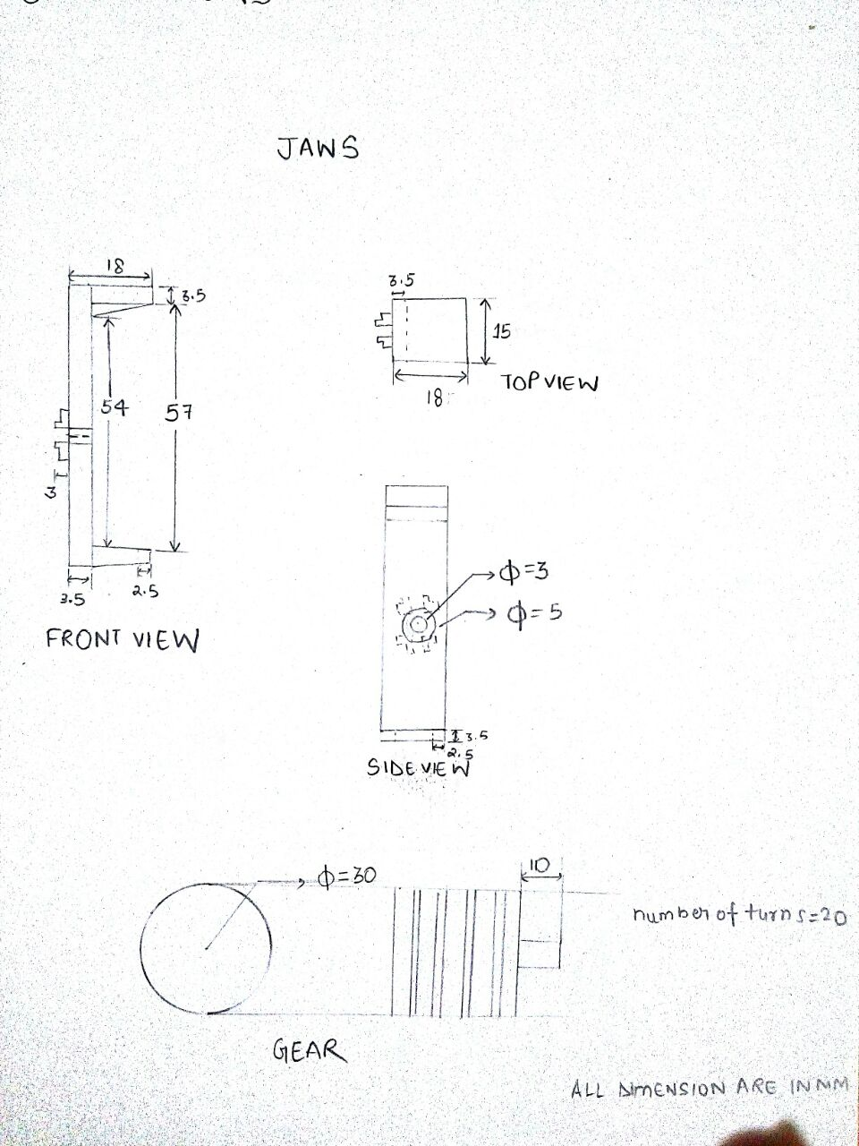 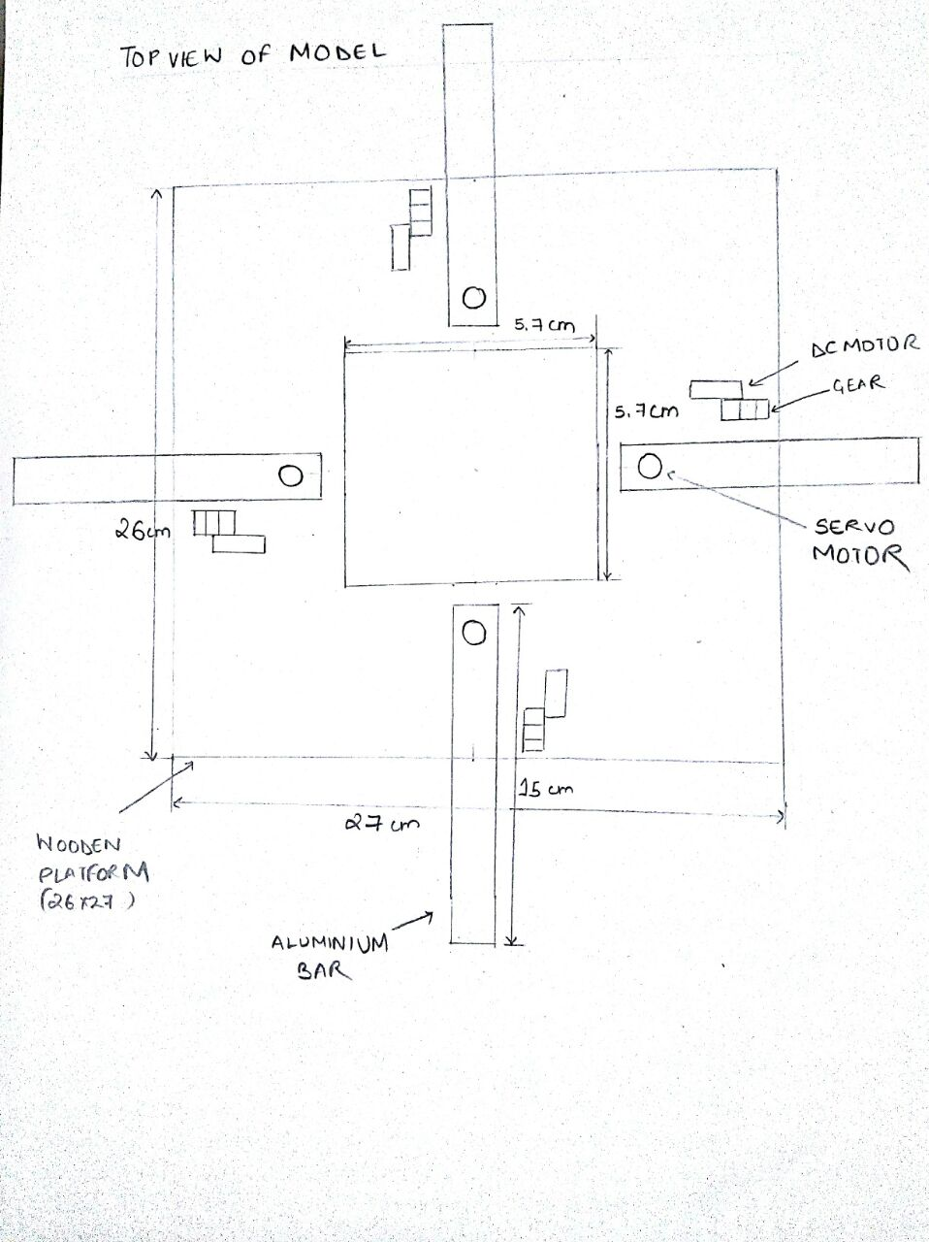

**2) METHODOLOGY:**

**2.1) DETAILS OF PROJECT**

The project can be categorised into following section:

* MECHANICAL DESIGN
* ELECTRONICS
* PROGRAMMING

1. **MECHANICAL DESIGN**

One of the most important parts of the robot was its mechanical design. The mechanical design would require a very high precision. Even a slight error of few millimetres would result in failure. The mechanical design consists of a wooden platform. Four stepper motor are mounted on it with utmost precision so that motors at opposite faces have their shafts coaxial. On each of these motors a gripper has been mounted which is driven by servo motors. These grippers are the part of the robot which will be in contact with the cube and provides the cube the necessary rotations. Using the combined of motion of these motors, the robot is able to provide rotation to all the six faces of the cube.

**i) Grippers**

Grippers are like robotic arms which are used to hold the cube. They are hand like mechanism which is able to open and close and remain at any particular angular position as desired. Grippers are made up of ABS polymer (3D printed).

**ii) Motors**

There are two kinds of motors used in this project namely DC motors and servo motors. Servo motor is a rotatory actuator that is used for precise control of the angular positions. They are a special kind of motors

that have the ability to rotate to a particular angle relative to its initial position. They are based on position feedback mechanism to control its motion and final position. Servo motors can be easily operated and can be used to provide a particular angular motion ranging from 0 to 180 degrees. Thus they can control the rotation of jaws followed by cube.

The other kind of motor is the DC motor. It provides the linear motion to rails with the help of rack and pinion gear arrangement. There are four such motors attached to four rails of the main frame.

1. **ELECTRONICS:**

The Arduino acts as the heart of the Cubinator. It gives commands to DC and servo motors. The Arduino is going to be powered by the PC. In total, 16 digital pins of Arduino will be used to control 8 motors, 4 servos and 4 DC motors.

1. **PROGRAMMING:**

The programming done can be summed into four parts (Module):

1. CUBE SIMULATOR (written in Python)
2. RUBIK’S CUBE SOLVER (implementing God’s Algorithm using Python)
3. ARDUINO SOFTWARE (written in C++)
4. SOFTWARE ADAPTER (written in Python)

**2.2) BLOCK DIAGRAMS:**

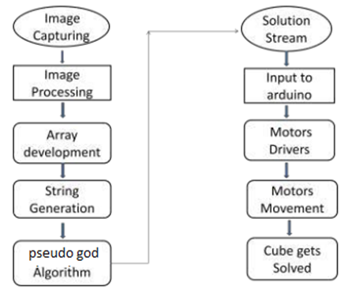

**2.3) SUMMARY:**

Cubinator is a machine which requires perfection. As it has been known Rubik’s cube is one of the most challenging and most famous puzzles of all time, our aim was to develop an autonomous robot which is capable of identifying colours of the cube and solve it in minimum time with minimum number of steps. Solving a Rubik’s cube has three major parts. First is identifying the positions of different colours at different positions. Second is to develop a series of steps which can be used to solve the cube and third is to implement these steps on the cube to get the final result. A manual input of colour and location of each tile if fed into the RubiK’s cube solver . Then a solving algorithm is applied on it which gives the desired solution step. The beauty of this algorithm is that it gives a maximum of only 20 moves to solve the cube where each step comprises of one rotation of respective face. This string of data is then fed into microcontroller which drives grippers that are attached to each of the motors as mentioned earlier. In this way our Cubinator solves even the most complex scrambled RubiK’s cube !

**2.4) FAILURES**

Earlier we planned to use Arduino camera for fully automated solution, but since we did not receive the Arduino camera we switched to android camera and tried to develop a simple image recognition software. Although it succeeded in standalone testing but it gave certain error while interfacing it with Arduino serial i/o. Thus we ended up in our last option to feed manual input (face positons and colours of each tile) to the computer. This increased the average time of solving cube by factor of 2. Thus, it was great unexpected failure for us and teach us many worthful things.

**2.5) FURTHER IMPROVEMENTS**

1. To get the interfacing between android camera and Arduino working perfectly.

2. To replace the dc motors with servo motors for more precise movements.

3. To develop our own code of cube solver algorithm so that we can adapt it to our own design.